**Defect Id:** 01

**Defect Title:**  Page not found error after clicking View Cart button

**Module:** Cart

**Priority:** High

**Repro Steps:**

1)Open URL in any browser.

2) Add product in cart

3) Click on the cart icon

4) Click on the view cart is working or not.

**Expected Result:**

1) Cart page should open up after clicking “View Cart” button.

**Actual Result:**

1) View cart button is not working showing error

**Snapshot:**

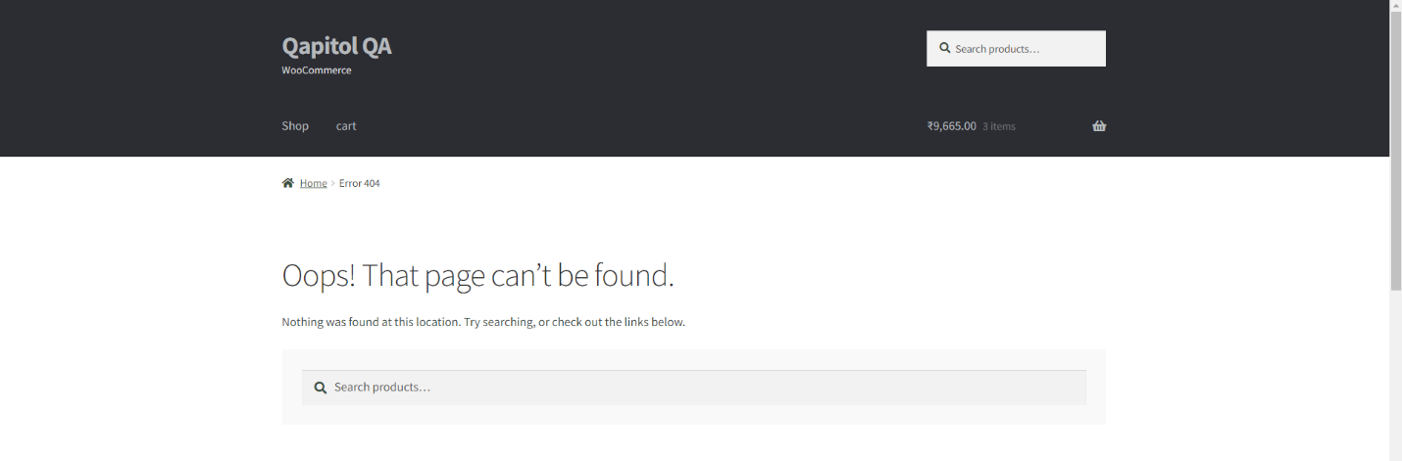

**Defect Id:** 02

**Defect Title:**  Page not found error after clicking Checkout button.

**Module:** Cart

**Priority:** High

**Repro Steps:**

1) Open URL in any browser.

2) Add product in cart.

3) Click on the cart icon.

4)Click on the Checkout button is working or not

**Expected Result:**

Checkout page should open up after clicking “Checkout”

**Actual Result:**

Page not found error after clicking “Checkout” button.

**Snapshot:** 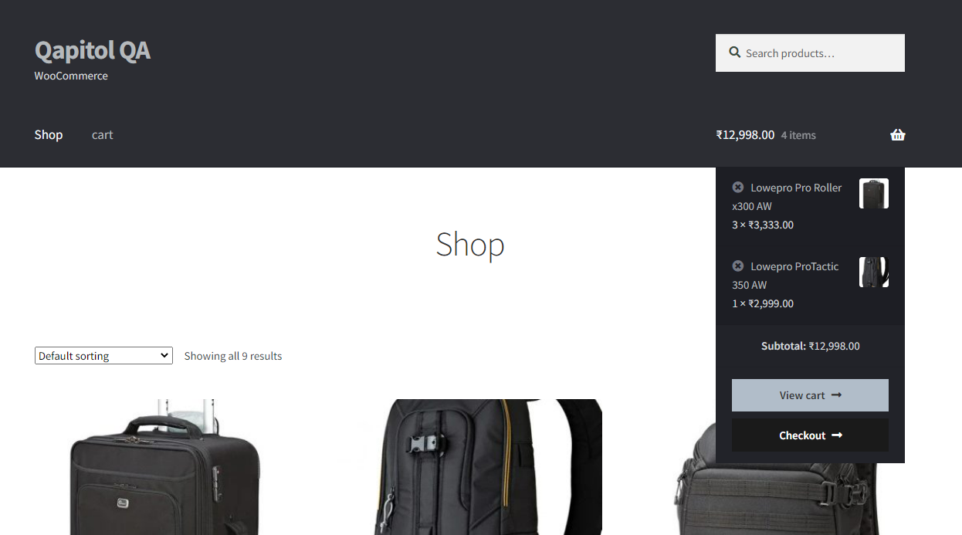

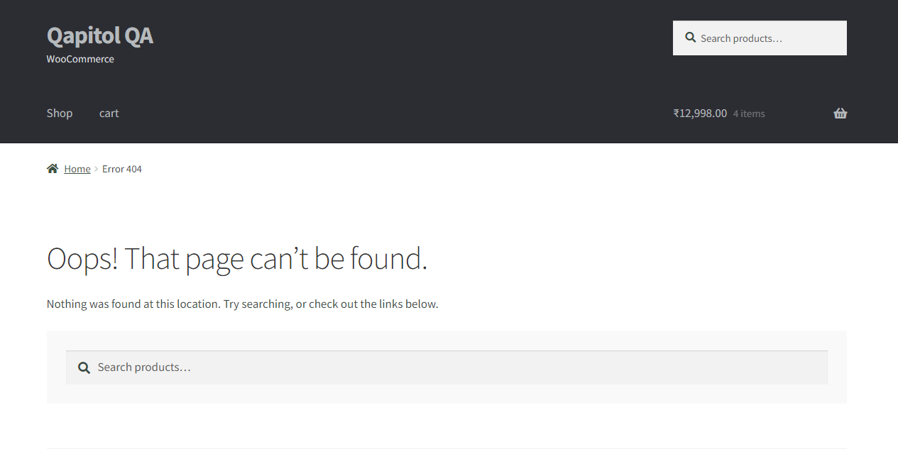

**Defect Id:** 03

**Defect Title:**  Search button inside the search field should be clickable.

**Module:** Search

**Priority:** Medium

**Repro Steps:**

1) Open URL in any browser.

2) Click on the search field.

3) Enter “Nikon”.

4) Click on search icon inside the text field.

**Expected Result:**

1) When user click on the search button with mouse It should display Search Result Page.

**Actual Result:**

1) Search icon is not working.

**Snapshot:**

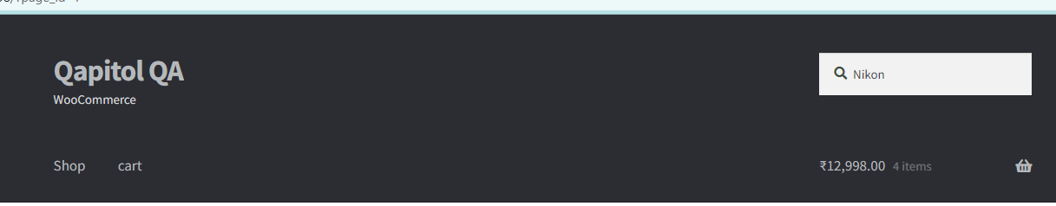

**Defect Id:** 04

**Defect Title:**  Home Page has two Dropdown.

**Module:** Dropdown.

**Priority:** High.

**Repro Steps:**

1) Open URL in any browser.

2) Verify that is has only one dropdown for search Product.

**Expected Result:**

1) Homepage should have only one dropdown for the search functionality.

**Actual Result:**

1) Home Page has two Dropdown.



**Snapshot:** 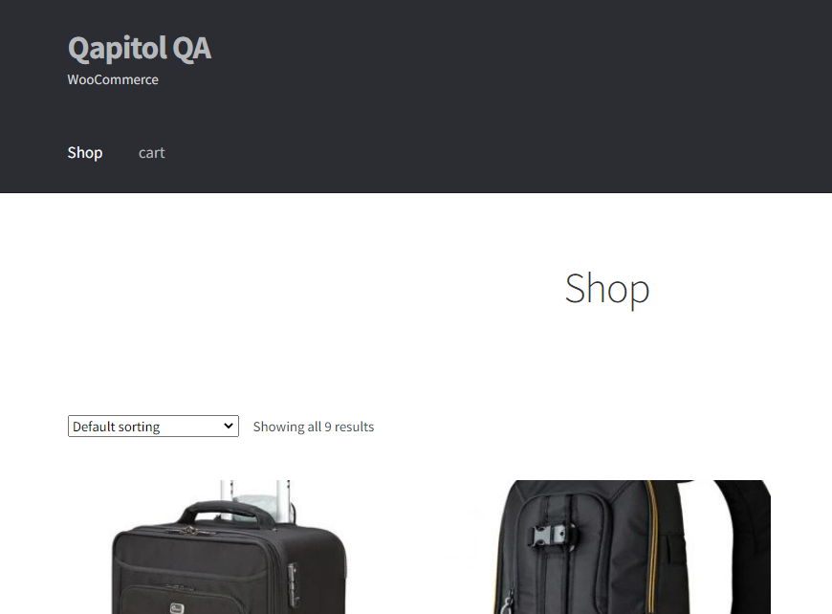



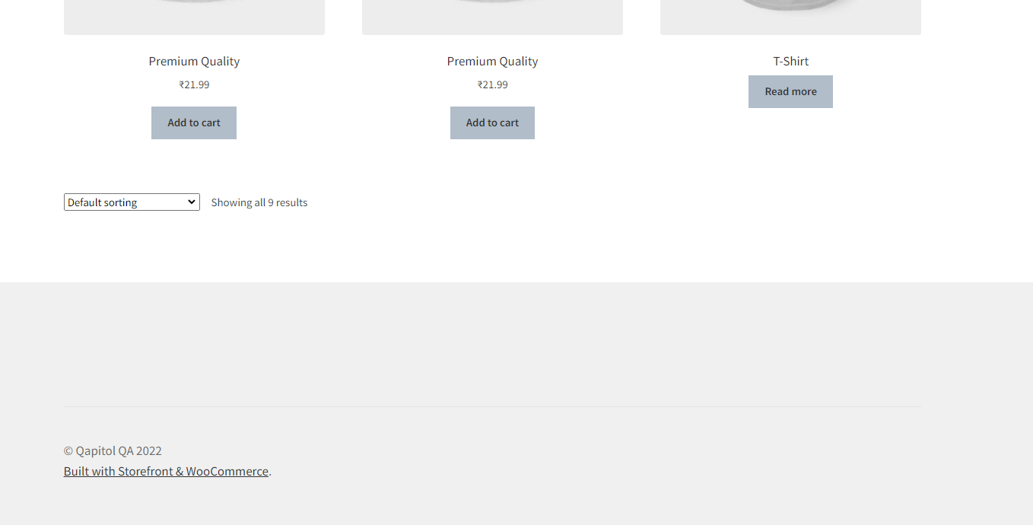

**Defect Id:** 05

**Defect Title:**  The message display is not appropriate.

**Module:** Review.

**Priority:** Medium.

**Repro Steps:**

1) Open URL in any browser.

2) Click on the search field and search product ("Lowepro ProTactic 350 AW").

3) Click on review tab and press submit button without providing any other details.

**Expected Result:**

1) Alert should display with "Please fill all the required fields and select start rating".

**Actual Result:**

1) Alert is displayed("Please select a rating").



**Snapshot:**

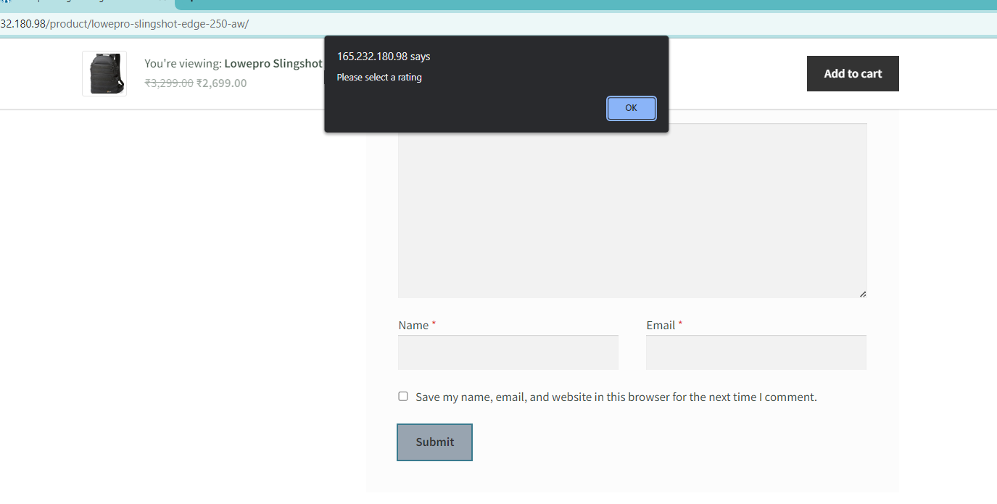

**Defect Id:** 06

**Defect Title:**  Cart icon is not appropriate.

**Module:** Cart.

**Priority:** Medium.

**Repro Steps:**

01) Open URL in any browser.

02) Click on the cart link and Verify that cart icon.

**Expected Result:**

01) Cart icon should display as per requirement.

**Actual Result:**

1. Sometimes cart icon gets distorted.



**Snapshot:**

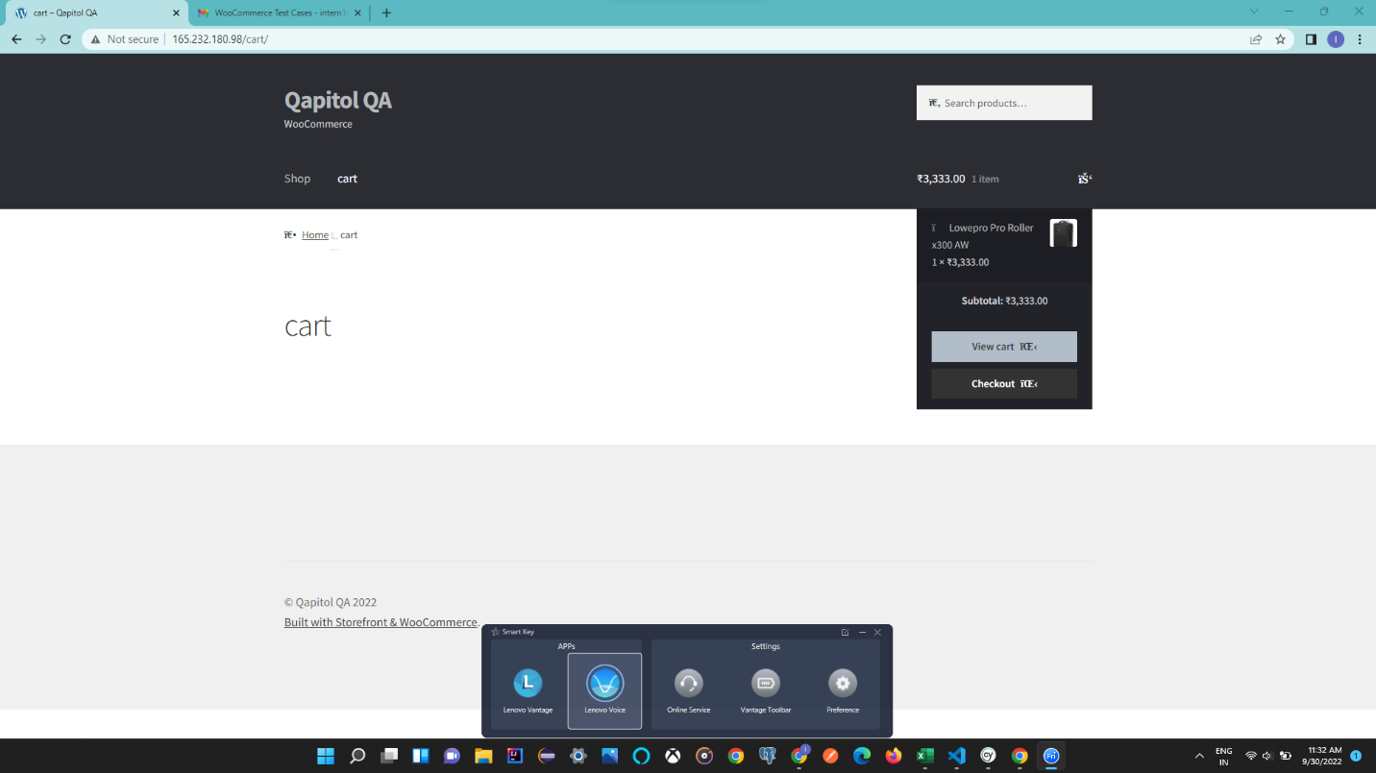

**Defect Id:** 07

**Defect Title:**  Add to cart button is missing.

**Module:** Product.

**Priority:** High.

**Repro Steps:**

1) Open URL in any browser.

2) Check on the Homepage all the product has add to cart button.

**Expected Result:**

1) All the products should have the add to cart button.

**Actual Result:**

1. Add to cart button is not available tshirt.



**Snapshot:**

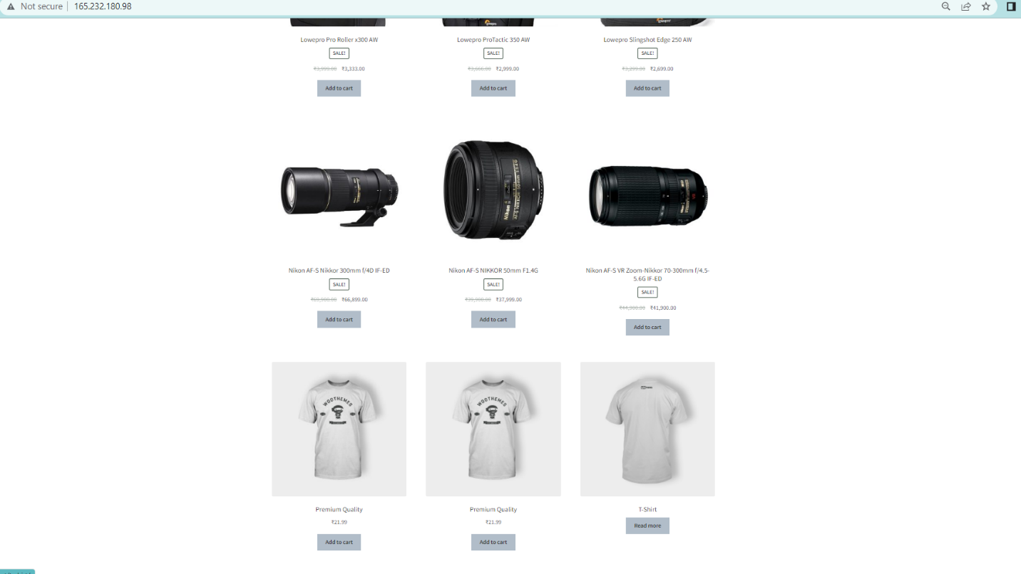

**Defect Id:** 08

**Defect Title:**  Product quantity box has no limit.

**Module:** Product.

**Priority:** High.

**Repro Steps:**

1) Open URL in any browser.

2) Click on any product and add 1400 quantity of that product into the cart.

**Expected Result:**

1) User should not allow to add more than 12 quantities.

**Actual Result:**

1. User can add 1400+ quantity into the cart.



**Snapshot:**

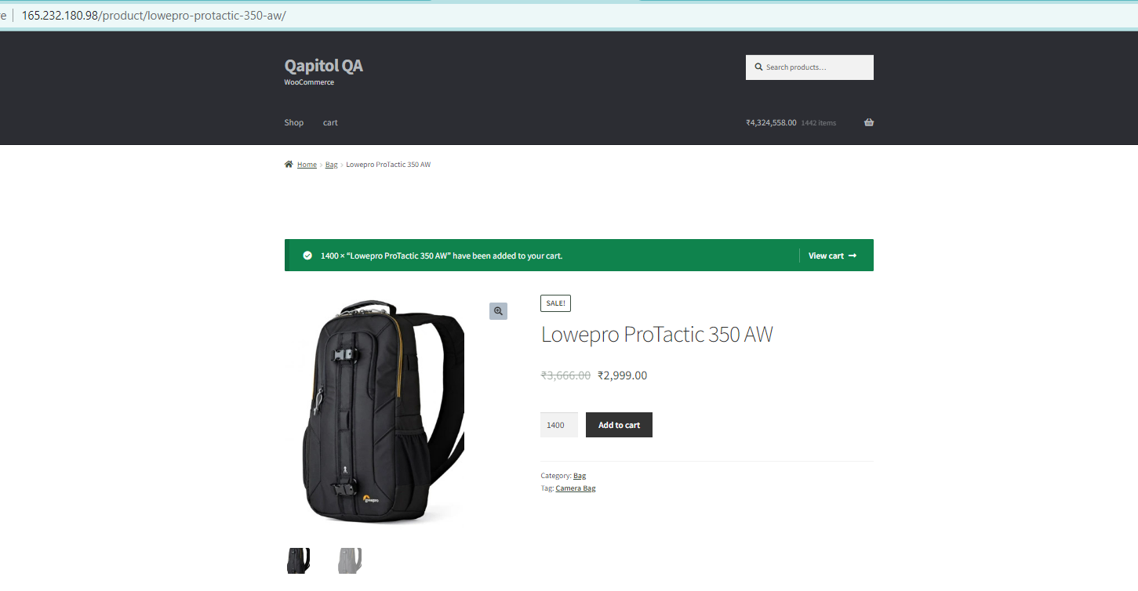

**Defect Id:** 09

**Defect Title:**  Related product is not center aligned.

**Module:** Product.

**Priority:** Medium.

**Repro Steps:**

1) Open URL in any browser.

2) Click on any product and verify that related product is center aligned or not.

**Expected Result:**

1) Related product section should center aligned.

**Actual Result:**

1. Related product section is left aligned.



**Snapshot:**

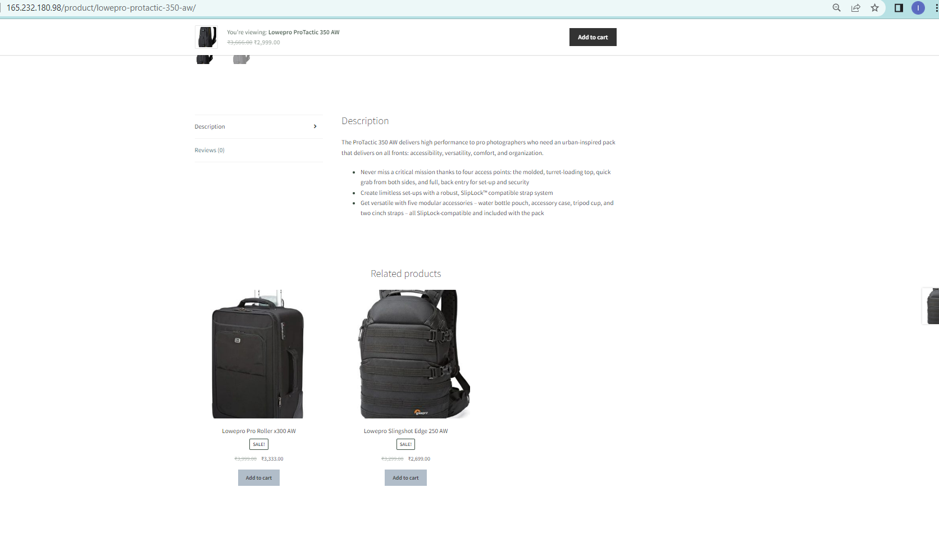

**Defect Id:** 10

**Defect Title:**  Search filed is not working for the correct input.

**Module:** Search.

**Priority:** High.

**Repro Steps:**

1) Open URL in any browser.

2) Click on the search field and type “Bag” and press enter.

**Expected Result:**

1)Bag related products should display.

**Actual Result:**

1. Error message is displayed “No products were found matching your selection.”.



**Snapshot:**

